**Set of 3 Islamic Frame set, Calligraphy Prints**

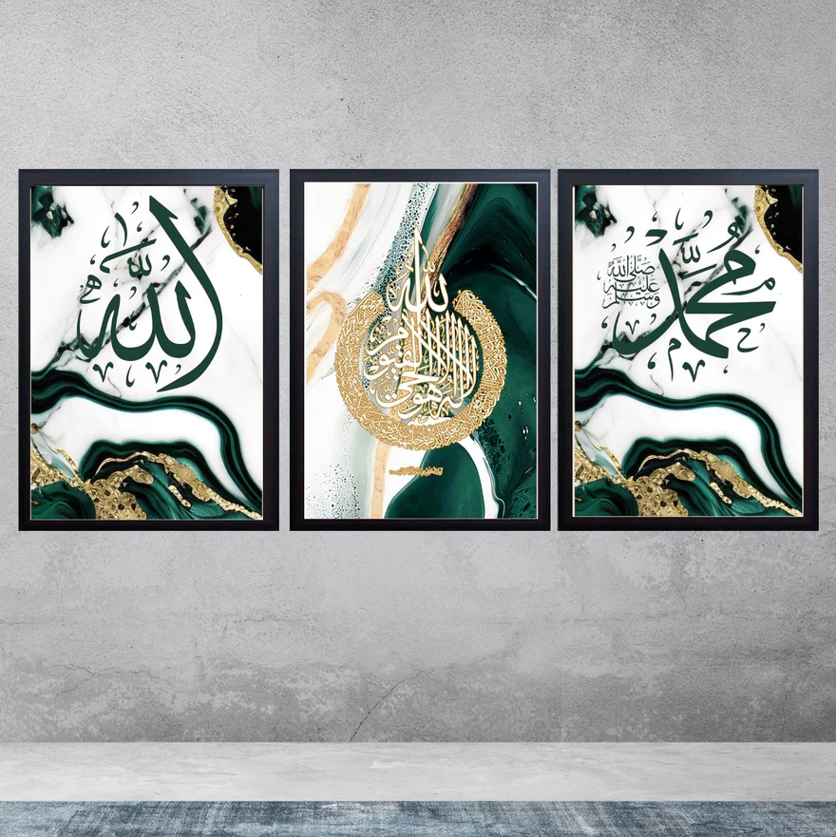The Set of 3 Islamic Frame Set featuring Calligraphy Prints is a beautiful and meaningful collection of artworks that brings the elegance of Arabic calligraphy into your home. Each print typically features sacred words, verses from the Quran, or names of Allah, designed in intricate, flowing script. The frames, often made from high-quality wood or metal, enhance the beauty of the calligraphy, making it a striking focal point in any room. Whether displaying names of Allah, Quranic verses, or other inspirational Islamic phrases, this set adds a sense of spirituality, peace, and reverence to your living room, bedroom, or prayer space. It’s an ideal addition for those seeking to enrich their home décor with art that reflects their faith and cultural heritage.